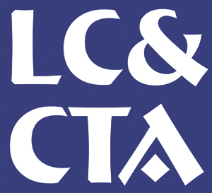Lewisham Counselling and Counsellor Training
Broadway House, 15-16 Deptford Broadway, SE8 4PA
Telephone 0208 320 2311
Email: enquiries@lcandcta.co.uk
BACP Approved Centre
CPCAB Approved Centre
Organisational Member of the NUS & BACP

YOUR NAME:

ADDRESS:

Telephone NO:

Email:

HPD Initial Assessment

Please answer each question in no more than 250 words using Harvard Referencing in the text when referring to theoretical concepts.

- Why do you want to study the Person-Centred Approach?
- What do you consider Rogers’ most important theoretical idea to be and why?
- What draws you to make application to study at LC&CTA

Please provide a brief explanation of the following Rogerian concepts in no more than 100 words using Harvard Referencing in the text when referring to these theoretical concepts.

- What are Conditions of Worth?
- What is organismic experience?
- Name the 3 Core Conditions and explain their meaning.

- Provide a Harvard Reference List for the references used in your text.

